**Build an OLX Progressive Web App for Pakistan**

OLX is one of the largest online classified ads directory in Pakistan and India. The company operates online marketplaces in over 40 countries, connecting local buyers and sellers.

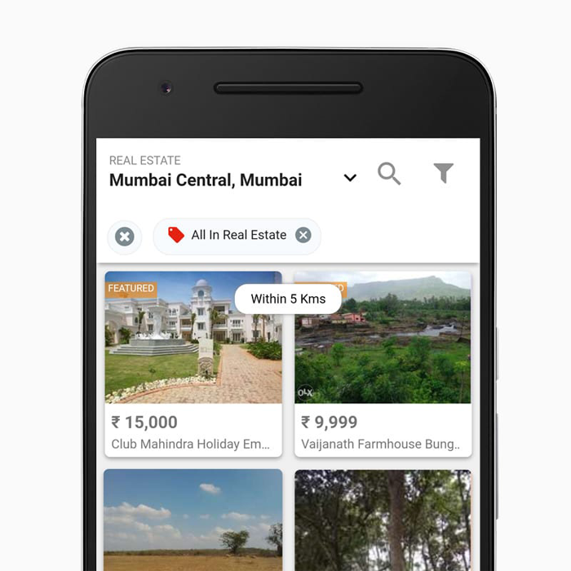

With over 90% of users on mobile, OLX India recognized the need to focus on its mobile user experience. They noticed most of the conversions came from their native app, and there was a higher bounce rate among mobile web users because of slow loading ads and pages.

OLX’s Progressive Web App build by India used engaging push notifications – just like a native app – and offered users an immersive, app-like experience on their mobile site.

**The Results: OLX boosts re-engagement on the mobile web by 250% with a Progressive Web App**

One of the largest online destinations for classified ads in India, OLX provides communities in high-growth markets with vibrant online marketplaces. They connect local people so they can buy, sell, or exchange used goods and services, making it fast and easy for anyone to post a listing on the web.

23% less time until page is interactive

80% lower bounce rates

146% higher CTR on Ads

250% more re-engagement

**Challenge faced by OLX India**

With declining desktop growth, OLX gets over 90% of their traffic from mobile devices—and this number is still growing. Half of their visitors come via their native app and half via the mobile website. OLX noticed, however, that the majority of conversions were still happening on the native app. Their mobile-web bounce rates tended to be higher as well.

OLX India analyzed behavior on their mobile site and realized their mobile web experience was too slow. Monetization also suffered from slow-loading ads. OLX aggressively doubled down on acquiring quality users and growing their engaged user base on the mobile web. They looked to Progressive Web App (PWA) technologies to provide a faster-loading, immersive and app-like experience.

**Solution implemented by OLX India**

OLX wanted to re-engage mobile web users, just as they would their mobile app users. On Android devices (which all support service worker, a key PWA technology), this meant taking advantage of re-engagement capabilities like push notifications and the “Add to Home screen” prompt.

With push notifications, OLX sends context-based alerts to tell users they have messages from buyers or sellers. These notifications look the same as those on native apps, and arrive even if the browser is no longer running. Over 600,000 users have signed up for notifications since the site launched in November 2016.

Altogether, these two updates increased engagement by 250%.

Creating a PWA improved other metrics too: the time until the page became interactive fell by 23%, with a corresponding 80% drop in bounce rates. Monetization also improved, with ads loading faster, the clickthrough rate (CTR) rising 146%. Their best-in-class PWA achieved a performance score of 92/100 on Lighthouse, an automated tool for improving web-page quality.

“In 2016 we re-invented classifieds mobile experience with the release of the new OLX App and its PWA. Building a new platform, we leveraged innovative technology and deep consumer understanding to roll out improved and forward-looking product changes that make the online classifieds experience safer, simpler, and social. Mobile being the first screen to ​ the​ internet for millions of users in India, we wanted to ensure that not only app-savvy users but people comfortable in using mobile websites can feel the same experience while using OLX. The PWA version feels like a natural app on the device, with an immersive user experience.”

Amarjit Batra, CEO,OLX India

**Check out the Indian OLX PWA App:**

<https://www.olx.in/>

If you go from your Android Chrome Browser to the above URL you will see the following:

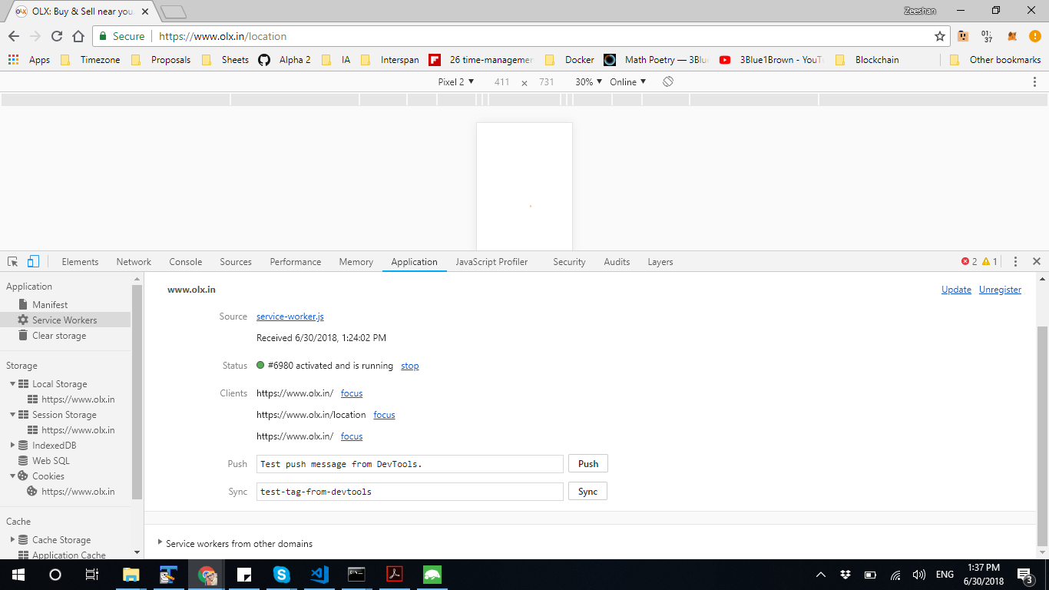

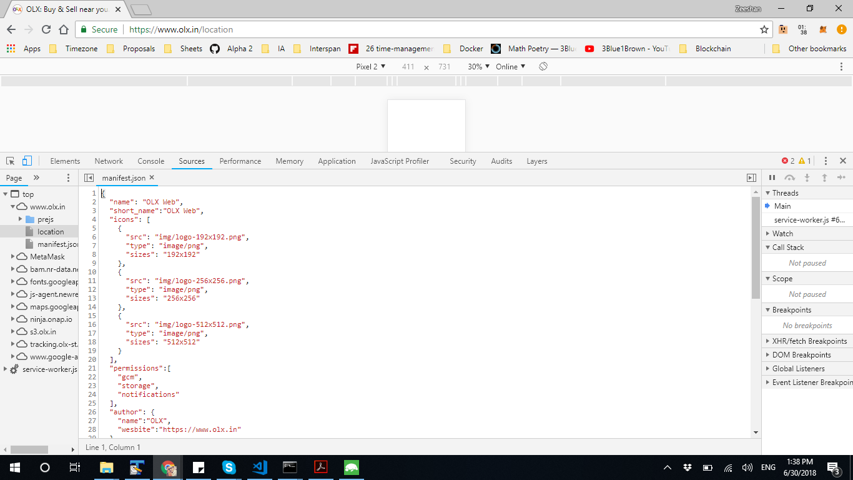

**Your Project: Build a Progressive Web App for OLX Pakistan**

You have been assigned the task of building a PWA which will be better than what was built by OLX India. In order to build a better and more scalable PWA we will do the following:

**We will use the Google Cloud technologies, to make the PWA more scalable:**

Firestore or Firebase Realtime Database:

<https://firebase.google.com/docs/firestore/>

<https://firebase.google.com/docs/database/>

Firebase Cloud Messaging:

<https://firebase.google.com/docs/cloud-messaging/>

Cloud Functions for Firebase:

<https://firebase.google.com/docs/cloud-messaging/>

You will host your PWA on Firebase Hosting:

<https://firebase.google.com/docs/hosting/>

**The PWA should be able to run on the following Platforms**:

1. Android Chrome
2. iPhones and iPads (iOS 11.3+)
3. Edge for Windows
4. Chrome on desktop operating systems

Read: <https://www.creativebloq.com/features/9-amazing-pwa-secrets>

**Functionality:**

1. Signup/Signin
2. Categories of Ads -- Single Level categories
3. Search Ads
4. Search Ads by category
5. Submit an Ad
6. Ad details like: Name, Description, Model, Year, Pictures, etc.
7. Send message on Ad to Seller or buyer
8. Mark an Ad to view later and can be viewed offline
9. Push notification when Buyer or seller send message

**Progressive web app features:**

1. Add to Home screen popup
2. Manifest.json
3. Offline availability with service-worker.js
4. If vendor updates the assets or resources then app gets updated on client
5. Push notifications, your OLX app will send context-based alerts to tell users they have messages from buyers or sellers. These notifications look the same as those on native apps, and arrive even if the browser is no longer running.